**Blinkit Analysis**

* See all the data imported:

SELECT * FROM blinkit_data

* **DATA CLEANING:**

Cleaning the Item_Fat_Content field ensures data consistency and accuracy in analysis. The presence of multiple variations of the same category (e.g., LF, low fat vs. Low Fat) can cause issues in reporting, aggregations, and filtering. By standardizing these values, we improve data quality, making it easier to generate insights and maintain uniformity in our datasets.

UPDATE blinkit_data

SET Item_Fat_Content =

CASE

WHEN Item_Fat_Content IN ('LF', 'low fat') THEN 'Low Fat'

WHEN Item_Fat_Content = 'reg' THEN 'Regular'

ELSE Item_Fat_Content

END;

After executing this query check the data has been cleaned or not using below query

SELECT DISTINCT Item_Fat_Content FROM blinkit_data;

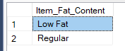

**A. KPI’s**

**1. TOTAL SALES:**

SELECT CAST(SUM(Total_Sales) / 1000000.0 AS DECIMAL(10,2)) AS Total_Sales_Millions

FROM blinkit_data;

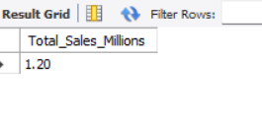

**2. AVERAGE SALES**

SELECT CAST(AVG(Total_Sales) AS DECIMAL(10,2)) AS Avg_Sales

FROM blinkit_data;

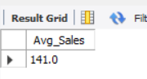

**3. NO OF ITEMS**

SELECT COUNT(*) AS No_of_Orders

FROM blinkit_data;

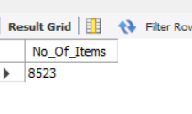

**4. AVG RATING**

SELECT CAST(AVG(Rating) AS DECIMAL(10,2)) AS Avg_Rating

FROM blinkit_data;

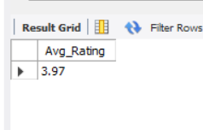

**B. Total Sales by Fat Content:**

SELECT Item_Fat_Content, CAST(SUM(Total_Sales)/1000 AS DECIMAL(10,2)) AS Total_Sales_Thousands

FROM blinkit_data

GROUP BY Item_Fat_Content

Order BY Total_Sales_Thousands DESC;

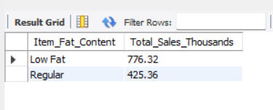

**C. Total Sales by Item Type**

SELECT Item_Type, CAST(SUM(Total_Sales) AS DECIMAL(10,2)) AS Total_Sales

FROM blinkit_data

GROUP BY Item_Type

ORDER BY Total_Sales DESC;

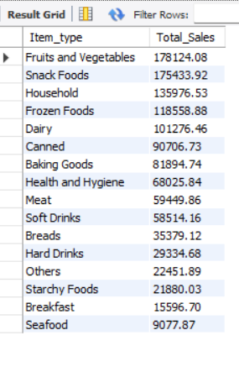

**D. Fat Content by Outlet for Total Sales**

SELECT

Outlet_Location_Type,

ROUND(SUM(CASE WHEN Item_Fat_Content = 'Low Fat' THEN Total_Sales ELSE 0 END), 2) AS Low_Fat,

ROUND(SUM(CASE WHEN Item_Fat_Content = 'Regular' THEN Total_Sales ELSE 0 END), 2) AS Regular

FROM blinkit_data

GROUP BY Outlet_Location_Type

ORDER BY Outlet_Location_Type;

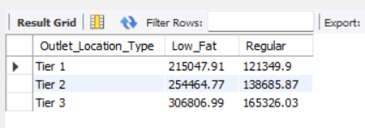

**E. Total Sales by Outlet Establishment**

SELECT Outlet_Establishment_Year,

ROUND(SUM(Total_Sales),2) AS Total_Sales

FROM blinkit_data

GROUP BY Outlet_Establishment_Year

ORDER BY Outlet_Establishment_Year ASC ;

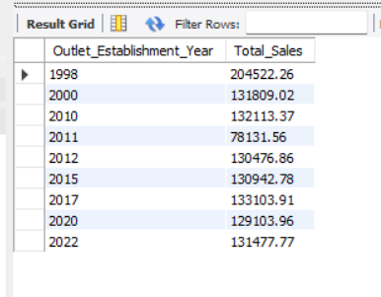

**F. Percentage of Sales by Outlet Size**

SELECT

Outlet_Size,

ROUND(SUM(Total_Sales), 2) AS Total_Sales,

ROUND((SUM(Total_Sales) * 100 / (SELECT SUM(Total_Sales) FROM blinkit_data)), 2) AS Sales_Percentage

FROM blinkit_data

GROUP BY Outlet_Size

ORDER BY Total_Sales DESC;

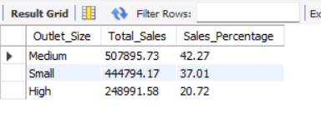

**G. Sales by Outlet Location**

SELECT Outlet_Location_Type,

ROUND(SUM(Total_Sales), 2) AS Total_Sales FROM blinkit_data

GROUP BY Outlet_Location_Type

ORDER BY Total_Sales DESC;

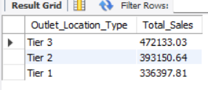

**H. All Metrics by Outlet Type:**

SELECT Outlet_Type,

ROUND (SUM(Total_Sales),2) AS Total_Sales,

ROUND((SUM(Total_Sales) * 100 / (SELECT SUM(Total_Sales) FROM blinkit_data)), 2) AS Sales_Percentage,

ROUND (AVG(Total_Sales),2) AS Avg_Sales,

COUNT(*) AS No_Of_Items,

ROUND (AVG(Rating),2) AS Avg_Rating,

FROM blinkit_data

GROUP BY Outlet_Type

ORDER BY Total_Sales DESC

